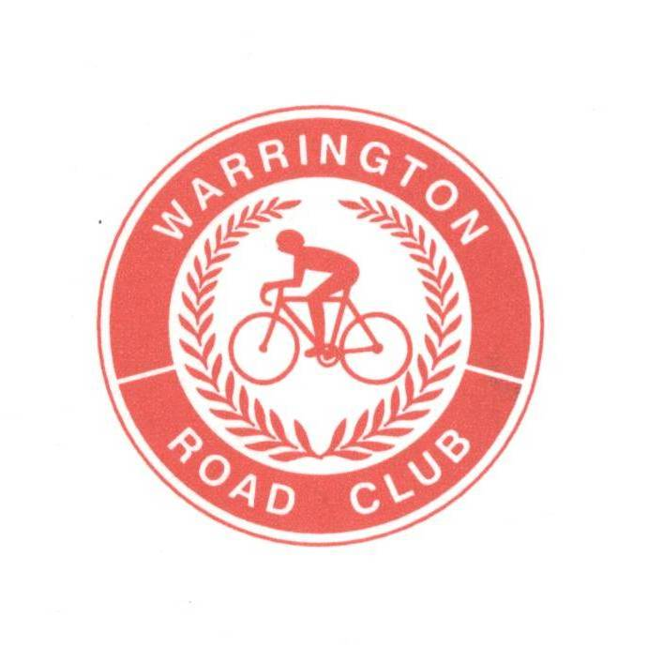
WARRINGTON ROAD CLUB

RESULTS SHEET
Event Secretary:
Darrell Webster
43 Farmleigh Gardens

25 MILE 2 UP TEAM TIME TRIAL

FOUNDED 1923
Great Sankey
Warrington
WA5 3FA
Tel: 01925 816874



PROMOTED FOR AND ON BEHALF OF CYCLING TIME TRIALS UNDER THEIR RULES AND REGULATIONS

SATURDAY 28th SEPT 2019 @ 2.00 pm - Course J2/9
TIMEKEEPERS Graham Lawrence and Ian Ross

Prize Winners (One team one prize)

Fastest Team

Position | Name | Club | Time | Prize
First | Alexander Royale  Adam Duggleby | Manchester Bicycle Club  Vive Le Velo | 50.04 | £70
Second | Ronnie Coleman  Stephen Feeney | Team Chronomaster  Team Chronomaster | 53.53 | £50
Third | Darren Roberts  Chris Southworth | Leigh Premier RC  Leigh Premier RC | 56.22 | £30

Fastest Club Team

Position | Name | Club | Time | Prize
First  Second | Phil Land  Steven Filder  Richard Cordin  Andrew Dearing | 3C Payments Sports  Matlock CC | 55.39  55.46 | £40  £30

Fastest Team with a Lady

Position | Name | Club | Time | Prize
First | Clare Harrison  David Ireland | Pro Vision Cycle Clothing  East Lancashire RC | 1.00.19 | £40

Thank you all for supporting this event. We had a good mixture of teams and great turnout despite the weather conditions.
Congratulations go to Alexander Royale & Adam Duggleby with a very convincing winning time of 50.04
I would like to say a big thank you to all the Marshals, Timekeepers and Headquarters officials for giving up their Saturday afternoon especially Alan Ottiwell who helped put the signs out and kept the HQ running whilst I was out on the course. I should also like to thank Julie & Caroline for serving the refreshments.
The event will back next year on Saturday 26th September 2020. Have a great winter and I hope to see you all again next year.

Kind regards

Darrell Webster
Warrington RC

